

DEPARTMENT OF COMPUTER SCIENCE
AND APPLICATIONS

IBM FINAL PROJECT
SALES TRENDS AND REVENUE PERFORMANCE STUDY
Submitted by
SHARMINI.H (222511549)
NITHYA.T (222511544)
DHIVYA SHREE.J (222312128)

BACHELOR OF SCIENCE IN COMPUTER
SCIENCE WITH ARTIFICIAL INTELLIGENCE

Under the guidance of
KAVIN CHAKARAVARTHI V M - Corporate Trainer

2025 - 2026

DECLARATION

We, Sharmini.H, Nithya.T and Dhivya shree.J, hereby declare that this project report on “Sales Trends and Revenue Performance Study” submitted to the University of Madras in partial fulfillment of the requirement for the award of the Degree Bachelor of Computer Science with Artificial Intelligence under the guidance of MRS.CAROLIN JOSHIPA S., HEAD OF DEPARTMENT and KAVIN CHAKARAVARTHI V M. has not been submitted earlier to any other university or institute for the award of any degree.

SHARMINI.H
NITHYA.T
DHIVYA SHREE.J

Place:
Date:

BONAFIDE CERTIFICATE
This is to certify that the project titled “Sales Trends and Revenue Performance Study” is the bonafide work done by, Sharmini.H, Nithya.T and Dhivya Shree.J hereby and First-year student of Jeppiaar College of Arts and Science, Padur, Chennai in partial fulfillment of the requirement for the award of the Degree of Bachelor of Computer Science with Artificial Intelligence 2025-2026.

PROJECT GUIDE: HEAD OF THE DEPARTMENT:

KAVIN CHAKARAVARTHI V M.

Date:

S. No | INDEX | Page No
 | Executive Summary
 | Introduction
 | Tools and Technologgies
Methodology

- Requirement Analysis
- Data Preparation
- Dashboard Design
- Testing
Implementation
- HTML Pages
- Styling
- Interactive Elements

Challenges and Solution
- Large Data Handling
- Data Accuracy
- Dashboard Resonsiveness

 | Key Features of the Dashboard
 | Result and Outcome
 | Conculation
 | Future Scop
 | Referance

Executive Summary

The Sales Trends and Revenue Performance Study analyzes historical sales data to identify key patterns and factors influencing revenue growth. Using data analytics and machine learning techniques, the study examines sales performance across products, regions, and time periods. Data preprocessing and exploratory data analysis were conducted to ensure accuracy and reveal meaningful trends.

Regression-based machine learning models were applied to predict revenue performance, and their effectiveness was evaluated using standard metrics such as R² score and Mean Absolute Error (MAE). The results highlight the impact of demand patterns, regional performance, and seasonal variations on revenue. This study demonstrates how data-driven insights can support better business decision-making, revenue forecasting, and strategic planning.

Introduction

In today’s competitive business environment, understanding sales trends and analyzing revenue performance are critical for strategic decision-making and sustainable growth. Businesses generate large volumes of sales data daily, and extracting meaningful insights from this data can help identify patterns, growth opportunities, and areas of improvement.
The study of sales trends involves examining historical data to detect seasonal fluctuations, product demand shifts, and regional performance variations. Revenue performance analysis evaluates how effectively a business generates income, considering factors such as sales volume, pricing, marketing campaigns, and customer behavior. By integrating data analytics and machine learning techniques, organizations can forecast future sales, optimize inventory, improve marketing strategies, and enhance overall revenue.
This study applies these methods to analyze structured sales data, providing actionable insights that support data-driven business decisions and contribute to efficient resource management and revenue optimization.

Abstract

This study focuses on analyzing historical sales data to understand sales trends and evaluate revenue performance. By applying data analytics and machine learning techniques, the research identifies patterns in product demand, seasonal variations, and regional performance. The dataset, comprising sales records across various products and regions, was preprocessed and explored using visualizations to highlight key trends. Regression-based models were implemented to predict revenue performance, and their accuracy was evaluated using metrics like R² Score and Mean Absolute Error (MAE). The study provides actionable insights to improve sales strategy, inventory planning, and revenue forecasting, demonstrating how data-driven decision-making enhances business performance in real-world scenarios

Tools and Technologies Used

➢ Data Analysis Tool (IBM Cognos / Excel / Power BI): For creating dashboards and reports.
➢ Microsoft Excel: For data cleaning and preparation.
➢ HTML & CSS: For displaying dashboards on web pages.
➢ JavaScript: For adding interactive features.
➢ Dataset Sources: Sales records, customer data, and revenue reports.

Methodology

1. Requirement Analysis:
Identified important sales and revenue indicators.
Selected suitable datasets for analysis.

2. Data Preparation:
Removed duplicate and incorrect data.
Organized data in proper format.

Dashboard Design

Created charts like bar graphs, pie charts, and line graphs.
Designed user-friendly layouts.

- Testing:

Checked accuracy of sales figures.
Verified dashboard performance.

- Deployment:

Published dashboards for users.
Made reports accessible online.

Implementation Details

HTML Pages:

Page 1: User login and input form.

Page 2: Displays sales and revenue dashboards.

Styling:

Used CSS for attractive design.

Added buttons and navigation menus.

Interactive Elements:

Filters for date, product, and region.

Dropdown menus for report selection.

Challenges and Solutions

Large Data Handling:

Challenge: Managing huge sales data.

Solution: Used data filtering and compression techniques.

Data Accuracy:

Challenge: Incorrect or missing values.

Solution: Cleaned data before analysis.

Dashboard Responsiveness:

Challenge: Display issues on mobile devices.

Solution: Used responsive web design.

Key Features of the Dashboard

Sales Trend Analysis: Shows monthly and yearly sales growth.

Revenue Monitoring: Tracks total income and profit.

Product Performance: Identifies best-selling products.

Region-wise Analysis: Displays sales by location.

User-Friendly Interface: Easy navigation and filtering.

Results and Outcomes

➢ Successfully analyzed sales and revenue data.
➢ Identified top-performing products and regions.
➢ Improved understanding of customer behavior.
➢ Provided useful insights for business planning.

Conclusion

The Sales Trends and Revenue Performance Study clearly shows that data analytics is an essential tool for modern business growth and success. By collecting, organizing, and analyzing sales and revenue data, this project helps in understanding business performance in a systematic way. The use of dashboards and visual reports makes complex data easy to understand and helps users quickly identify important patterns and trends.

Through this study, the organization can monitor sales activities, track revenue growth, and evaluate the performance of products and regions. It also helps in identifying customer preferences and market demand, which are important for improving business strategies. The analysis supports management in making accurate and timely decisions based on real data rather than assumptions.

Moreover, this project improves operational efficiency by highlighting weak areas and opportunities for improvement. By using the insights gained from this study, companies can plan better marketing strategies, manage resources effectively, and increase customer satisfaction. Overall, this project proves that proper analysis of sales and revenue data leads to better planning, higher profitability, and long-term business development.

Future Scope

Real-Time Data Integration: Connect with live sales systems.

Predictive Analysis: Forecast future sales trends.

AI-Based Recommendations: Suggest marketing strategies.

Mobile Application Support: Access reports on smartphones.

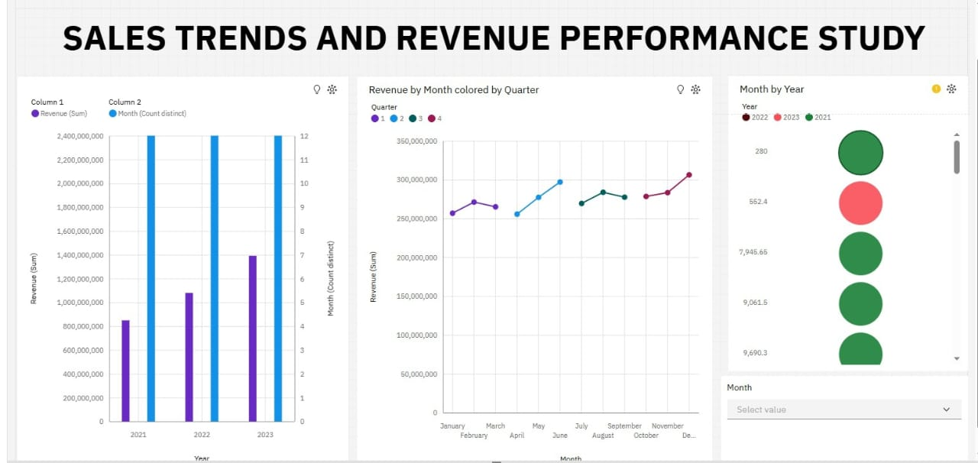

References
- click here to git
- clic here to data set

